Stardew Valley Bundle Manager

Brittney MacLennan

University of Missouri – Kansas City

Table of Contents
Vision Statement 3
Requirements 4
Product Backlog 5
Sprint #1 6
Review 6
Retrospective 6
Sprint #2 7
Review 7
Retrospective 7
Sprint #3 8
Review 8
Retrospective 8
Sprint #4 9
Review 9
Retrospective 9
Sprint #5 10
Review 10
Retrospective 10
Sprint #6 11
Review 11
Retrospective 11

Vision Statement

With this project, I am aiming to create an app that will help players of the game Stardew Valley be able to track “bundles” from the Community Center in their game. These bundles are made up of various items that will unlock rewards when all of them are collected. The key features of this app will consist of a list that will allow users to keep track of what items they have already found and what items they still need to collect.
The reason for creating this app is because I have often found myself wondering what items I still need to collect for the Community Center when I am playing the game, but the only way to see what items are still required is to go to the Community Center in the game which can take time away from other tasks depending on where you are on the map. My hope is that this app will prove useful to players as they will no longer have to go into town to check their progress and instead be able to check their phone and continue working on their other goals.
Depending on how difficult coding proves to be, the immediate release will be a barebone list that syncs to a database so that user progress is saved when the app is closed. Users will be able to click on the items under the bundle types to mark them as collected. If the coding is not too difficult, I would like to make the menu more aesthetically pleasing by adding images from the game and making a user interface that resembles what is seen in the game.
Stretch goals consist of allowing users to have multiple trackers going for different characters as users can create multiple characters in the game. Another stretch goal is to allow the switching of menu types between an image-based UI compared to a text-only IU for those that have a preference between the two.

Requirements
A discussion of what your application is required to have in functionality. It should identify user roles and goals/actions, and what the key features of the app should be.
Actor | Goal
Users | Want an app that looks nice and is easy to use.
Users | Want their choices to persist after the app is closed.
Users | Would like to track bundles over multiple characters.
Users | May enjoy the ability to switch between compact and non-compact UI.
Team Lead | Wants the app to be shared by word of mouth by happy users.
Team Lead | Wants to create an app that users will use over similar apps.
Team Lead | Wants to create a project they themselves would use.

Product Backlog
This will be updated throughout the semester as new PBIs are added, larger items are broken into smaller ones, and completed items removed.

Story ID | Story | Story Points  (in est. hours) | Priority | Status

Sprint #1

Sprint Backlog
Story ID | Story / Task | Estimated  Hours | Actual  Hours
1 | Background | 2 | 1.5
2 | Logo | 2 | 1.5
3 | Title Screen | 3 | 2

Review
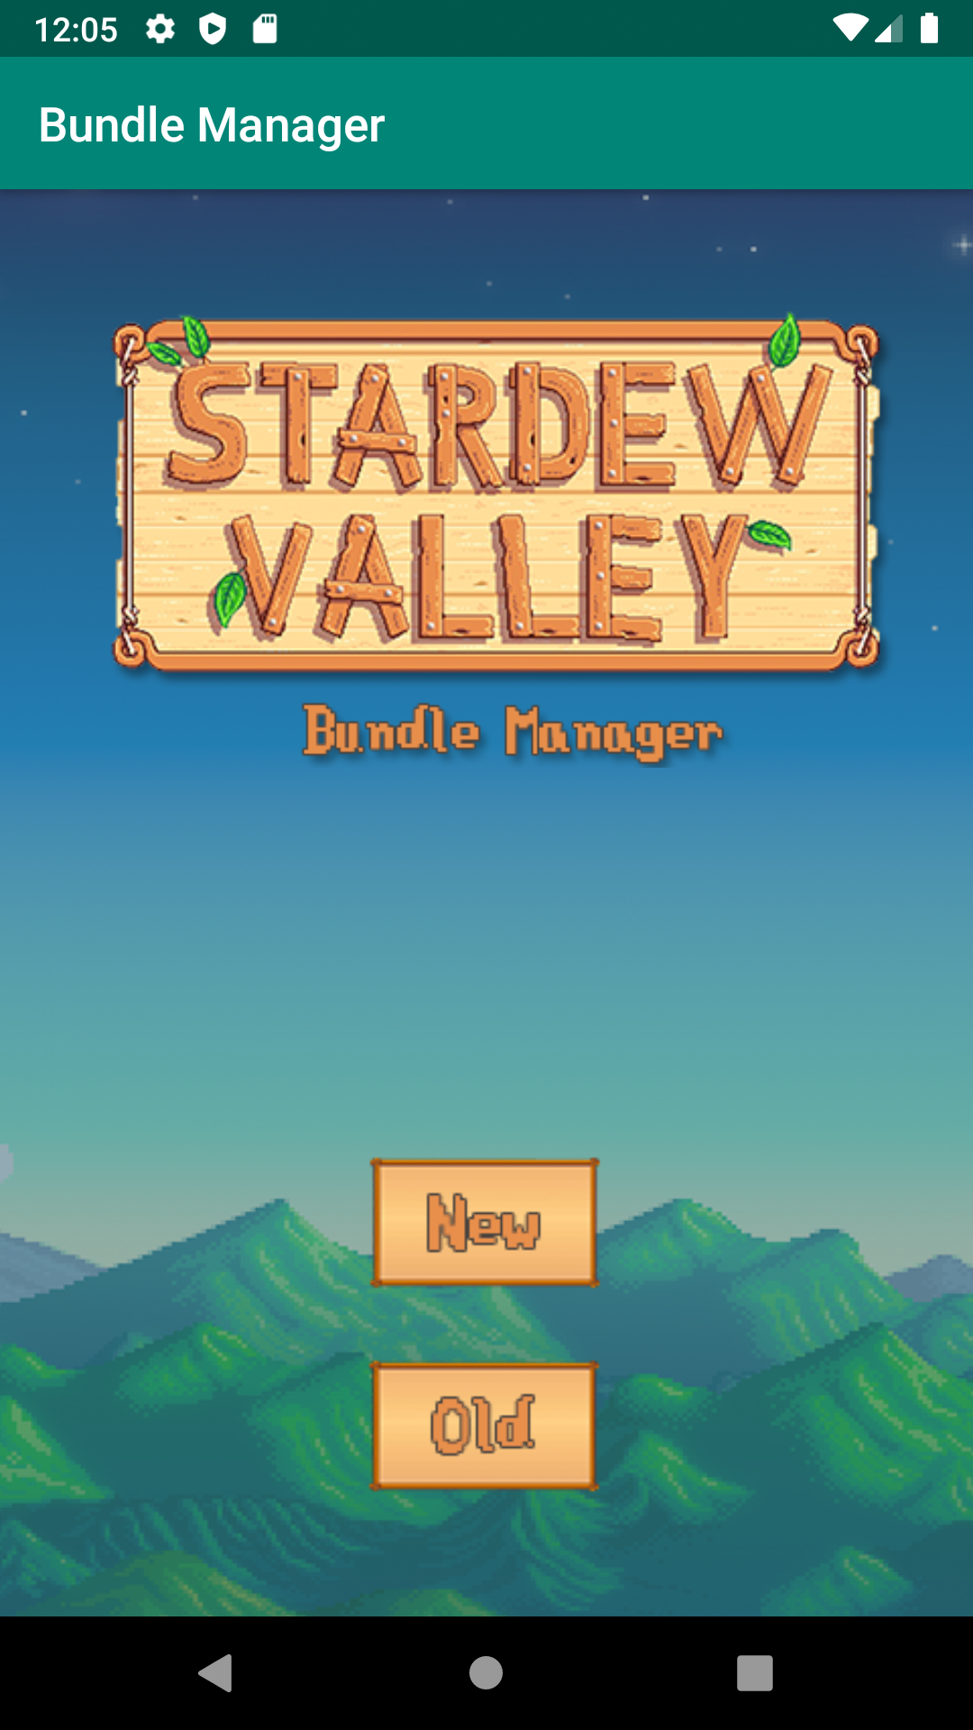 | The first sprint was spent designing a startup screen for the app that looked aesthetically pleasing and fit with the theme of the game. I feel that this was accomplished, though the buttons currently on the screen are subject to change depending on how future sprint goes and whether multiple bundles will be possible. Everything planned for this sprint was accomplished.

Retrospective
I believe that I played this sprint relatively safe and that I could have combined the goals I initially made for spring 2 into the first sprint as well. However, my time management for this sprint went well and that is something I would like to carry into spring 2, especially since I think spring 2 will be where the project will start to become challenging. I think going into the future sprints that I will plan to do more rather than less and if those goals are not accomplished add them to the Product Back Log instead of feeling like I failed by not finishing them during the sprint.

Sprint #2

Sprint Backlog
Story ID | Story / Task | Estimated  Hours | Actual  Hours
4 | User Interface | 4
5 | List Layout | 4

Review

[Screenshots, etc go here. This is where you discuss the product, describing what was done this sprint (potentially shippable product increment) and what was planned for the sprint but was not done. ]

Retrospective
[This is where you discuss the process. What went well (and are you planning to do more of that?) What didn’t go so well (and do you have a way to do less of that)? What changes are you planning to make in how you plan & carry out the next sprint?]

Sprint #3

Sprint Backlog
Story ID | Story / Task | Estimated  Hours | Actual  Hours
6 | Interactable List | 6

Review

[Screenshots, etc go here. This is where you discuss the product, describing what was done this sprint (potentially shippable product increment) and what was planned for the sprint but was not done. ]

Retrospective
[This is where you discuss the process. What went well (and are you planning to do more of that?) What didn’t go so well (and do you have a way to do less of that)? What changes are you planning to make in how you plan & carry out the next sprint?]

Sprint #4

Sprint Backlog
Story ID | Story / Task | Estimated  Hours | Actual  Hours
7 | Create Database | 5
8 | Sync Database Choices | 8

Review

[Screenshots, etc go here. This is where you discuss the product, describing what was done this sprint (potentially shippable product increment) and what was planned for the sprint but was not done. ]

Retrospective
[This is where you discuss the process. What went well (and are you planning to do more of that?) What didn’t go so well (and do you have a way to do less of that)? What changes are you planning to make in how you plan & carry out the next sprint?]

Sprint #5

Sprint Backlog
Story ID | Story / Task | Estimated  Hours | Actual  Hours
9 | Create image-based UI for list | 8

Review

[Screenshots, etc go here. This is where you discuss the product, describing what was done this sprint (potentially shippable product increment) and what was planned for the sprint but was not done. ]

Retrospective
[This is where you discuss the process. What went well (and are you planning to do more of that?) What didn’t go so well (and do you have a way to do less of that)? What changes are you planning to make in how you plan & carry out the next sprint?]

Sprint #6

Sprint Backlog
Story ID | Story / Task | Estimated  Hours | Actual  Hours
10 | Allow users to track multiple bundles | 10

Review

[Screenshots, etc go here. This is where you discuss the product, describing what was done this sprint (potentially shippable product increment) and what was planned for the sprint but was not done. ]

Retrospective
[This is where you discuss the process. What went well (and are you planning to do more of that?) What didn’t go so well (and do you have a way to do less of that)? What changes are you planning to make in how you plan & carry out the next sprint?]

